A Project Report On

#### SKIN CARE PRODUCTS RECOMMENDATION SYSTEM

|  |  |  |
| --- | --- | --- |
|  | Table of Contents |  |
| Chapter | TITLE | Page No |
|  | Abstract | 1 |
| 1 | Introduction | 2 |
| 2 | System Requirements | 6 |
|  | 2.1 Software Requirements | 6 |
|  | 2.2 Hardware Requirements | 7 |
|  | 2.3 Data Set | 9 |
| 3 | Literature Survey | 14 |
| 4 | Propose Approach , Modules Description, and UML Diagrams | 17 |
|  | 4.1 Modules | 17 |
|  | 4.2 UML Diagrams | 24 |
| 5 | Implementation, Experimental Results &Test Cases | 29 |
| 6 | Conclusion and Future Scope | 37 |
| 7 | References | 38 |
|  | Appendix   1. Full Paper-Publication Proof 2. Snapshot Of the Result 3. Optional (Like Software Installation /Dependencies/ pseudo code) | 39  40 |

|  |  |  |  |  |
| --- | --- | --- | --- | --- |
|  | | **List of Figures** |  | |
| **Fig No** | | **Fig Title** | **Page No** | |
| 1.1.1 | | Skincare Products | 3 | |
| 1.1.2 | | Main Products | 3 | |
| 2.1.1 | | Python System requirements | 6 | |
| 2.1.2 | | Software requirements | 7 | |
| 2.3.1 | | Dataset | 10 | |
| 2.3.2 | | Dry Folder | 10 | |
| 2.3.3 | | Dry Sample | 11 | |
| 2.3.4 | | Oily Folder | 11 | |
| 2.3.5 | | Oily Sample | 12 | |
| 2.3.6 | | Normal Folder | 12 | |
| 2.3.7 | | Normal Sample | 13 | |
| 4.2.1 | | CNN | 19 | |
| 4.2.2 | | Tensor flow | 20 | |
| 4.2.3 | | NumPy | 21 | |
| 4.2.4 | | Matplotlib | 22 | |
| 4.3.1 | | Use case diagram1 | 25 | |
| 4.3.2 | | Activity diagram | 26 | |
| 4.3.3 | | System architecture | 27 | |
| 4.3.4 | | Use case diagram2 | 28 | |
| 5.1 | | Fig 5.1 | 29 | |
| 5.2 | | Fig 5.2 | 30 | |
| 5.3 | | Fig 5.3 | 30 | |
| 5.4 | | Fig 5.4 | 31 | |
| 5.5 | | Fig 5.5 | 31 | |
| 5.6 | | Fig 5.6 | 32 | |
| 5.7 | | Fig 5.7 | 32 | |
| 5.8 | | Fig 5.8 | 33 | |
| 5.9 | | Fig 5.9 | 33 | |
| 5.10 | | Fig 5.10 | 34 | |
| 5.11 | | Fig 5.11 | 34 | |
| 5.12 | | Fig 5.12 | 35 | |
| 5.13 | | Fig 5.13 | 35 | |
| 5.14 | | Fig 5.14 | 36 | |
| 5.15 | | Fig 5.15 | 36 | |
| 7.1 | | Paper Publication proof | 39 | |
| 7.2 | Stream lit Representation | | | 40 |

|  |  |  |
| --- | --- | --- |
|  | **LIST OF TABLES** |  |
| **Table No** | **Table Name** | **Page No** |
|  |  |  |

# ABSTRACT

A machine learning-based recommendation system for skin care goods is an individualized tool that makes product recommendations to consumers based on their skin type and preferences. First, we give the user's face as input, and the system examines several aspects of their face. This analysis enables the system to comprehend the particular wants and preferences for attractiveness while also revealing insights into the user's distinct face traits. Following input, the user's skin type is determined, and goods such as serum, face wash, moisturizer, and sunscreen are suggested according to the user's skin type. The system's recommendations are extremely tailored and unique, taking into account each user's requirements, preferences, and distinct face features. Through constant learning from user interactions and feedback, machine learning algorithms are able to update and optimize the suggestions.

The desire for customized beauty treatments and rising consumer awareness have propelled the skincare industry's exponential rise. To improve user pleasure and engagement, a Skin Care Products Recommendation System in this scenario makes use of advanced machine learning and data analysis tools to provide customized product recommendations. The strategy merges product properties like ingredients, efficacy, and user ratings with user-specific data like skin type, concerns, preferences, and environmental conditions. Through the use of content-based filtering, hybrid recommendation models, and collaborative filtering, the system is able to forecast and suggest skincare items that are most suited to individual needs.  
  
Complete user profile setup, interactive feedback systems, and real-time suggestion updates are some of the key characteristics. The system complies with applicable laws and industry best practices to ensure privacy and data security. By use of a simple user interface, It is a useful tool for customers looking for the best skincare solutions as well as for businesses looking to increase customer loyalty and stand out in the market since it offers actionable data and tailored suggestions.  
  
Thorough testing and user feedback are used to assess the recommendation system's efficacy, showing notable increases in customer happiness and product relevancy. The core of creating an advanced, user-focused skincare recommendation system that leverages artificial intelligence to revolutionize the skincare buying experience is captured in this picture.

# 

# 1. INTRODUCTION

# 1.1 Introduction to Project

# 

The market for skincare products is expanding as people realize how important it is to have customized skincare regimens that meet their individual demands. Finding the best solutions for their particular skin type and problems may be difficult, though, due to the broad spectrum of alternatives available. Our research is to use the latest advances in machine learning and artificial intelligence to create a sophisticated skincare Recommendation System in order to address this problem.  
  
Goals :  
Our project's main goal is to develop a customized system of recommendations that can recommend the best skin care products that match each user's unique profile. These user profiles will be developed with a number of data points, such as:  
  
Skin Type: Normal, oily, combo, dry, or sensitive.  
Problems with the skin includes dehydration, pigmentation, aging, acne, as well as sensitivity.

# Brand choices, sensitivity to ingredients (allergies, for example), and product categories (vegan, cruelty-free, etc.) are examples of preferences.

# Environmental factors include the climate of the area, levels of pollution, and other circumstances that may have an impact on skin health.

Essential Parts:  
Design of User Profiles: Users will provide comprehensive data on their interests, concerns, and skin type. The suggestion procedure is built around this information.  
  
Data Integration: To guarantee thorough and precise suggestions, the system will combine data from a variety of sources, such as user evaluations, ingredient lists, product databases, and clinical studies.  
  
Algorithms for Suggestions:  
Using information from comparable users, collaborative filtering makes product recommendations.

Content-Based Filtering: Generates suggestions by examining user preferences and product attributes.

Hybrid Models: Provides more reliable and precise recommendations by combining content-based and collaborative filtering.

Feedback Loop: By letting users comment on the suggestions they get, the system can improve its algorithms and provide better suggestions in the future.  
  
The User Interface: An intuitive design facilitates easy data entry for users and guarantees smooth interaction.

By offering individualized and highly tailored product suggestions based on unique customer preferences and skin types, a machine learning-powered beauty product recommendation system has the potential to completely transform the skincare sector. Targeted skincare treatments are made possible by the system's usage of advanced face analysis tools to comprehend each user's unique facial traits. Among the main advantages of such a structure are growth of the industry

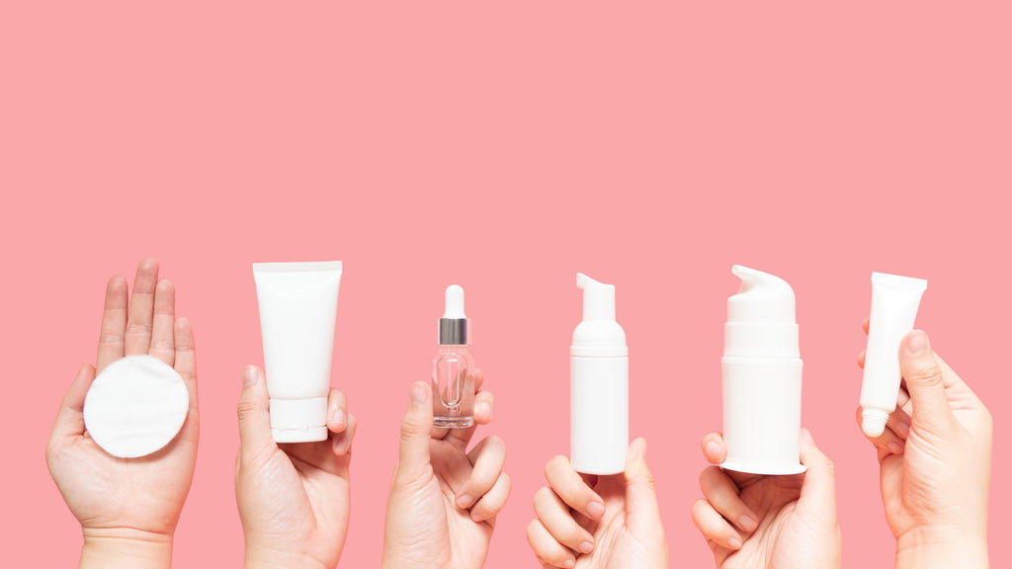

1.1.1 Skin care products

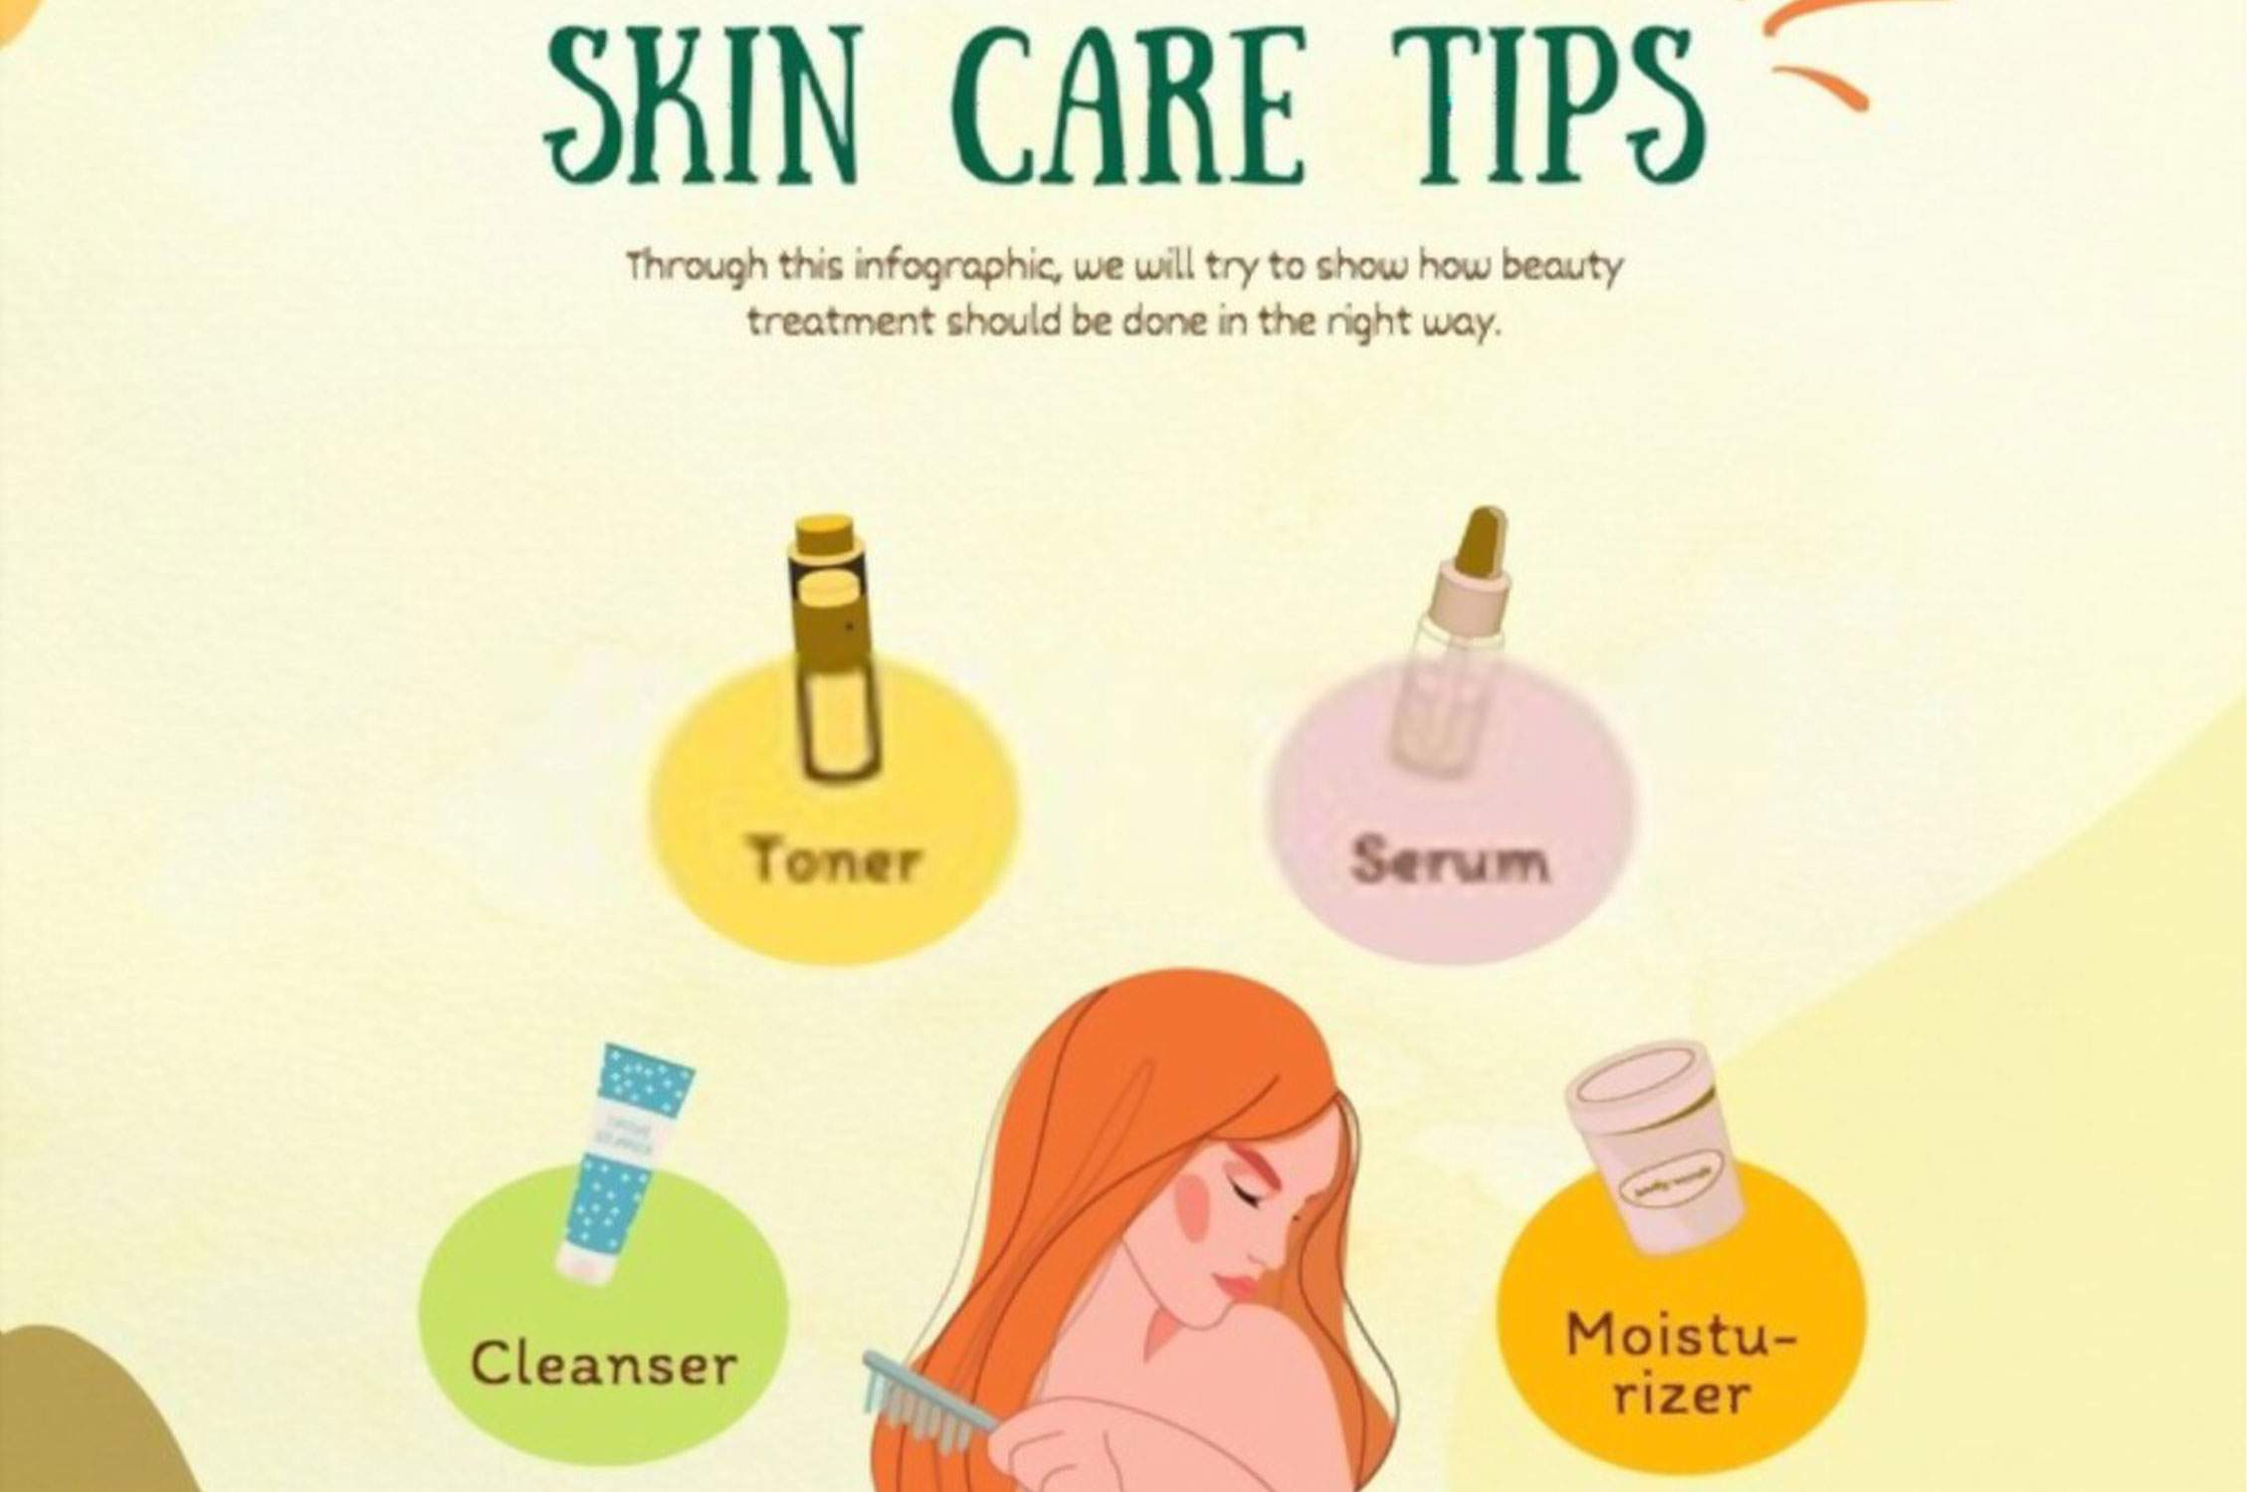

1.1.2 Main Products

**1.2 Existing System**

Lack of Personalization: Current beauty suggestion systems frequently fall short in terms of tailoring advice according to individual characteristics like age, skin tone, kind of skin, and preferences. In order to guarantee that consumers receive ideas that are pertinent to their particular requirements, personalization is crucial.   
  
Restricted Diversity in Recommendations: A limited range of items that fails to meet the diverse demands of customers is the outcome of certain beauty recommendation systems' lack of diversity in product suggestions. This may result in the neglect of specialized or emerging businesses and a failure to adequately reflect the range of skin tones and ethnic preferences.

Countless recommendation engines have emerged in the skincare sector to assist customers in selecting the ideal products. These systems vary from simple recommendation engines to complex AI-powered networks. An outline of various current systems, together with information on their features and methods, is provided below.

Simple Filtering Mechanisms: Based on little user input, these systems provide straightforward suggestions based on factors like skin type and principal skin problem. Usually, they propose items based on pre-established guidelines. For instance, basic filtering is used by online retailers such as Amazon and Sephora to classify items and provide recommendations according to broad tags such "oily skin" or "wrinkle prevention."

Systems of Content-Based FilteringContent-based filtering systems connect product attributes to user profiles by analyzing product attributes. They concentrate on the features that products have.

# 

# 1.3 Proposed System

The main goal is to develop a system that recommends cosmetic goods to consumers determined by their skin type, preferences, and financial situation.

There are a few important phases in developing a recommendation system for beauty items. First and foremost, data collecting is crucial. This includes learning about customer preferences and compiling detailed information on beauty goods. User profiling is essential for capturing individual preferences, such as skin type, worries, and financial limitations, once data has been gathered. The next step is algorithm selection, in which the project's specifications are used to determine whether recommendation algorithms—such as content-based or collaborative filtering—are suitable. To produce precise recommendation models, model training is then carried out utilizing past user-product interaction data. Additionally, feedback integration is essential since it enables the recommendation system to be continuously improved.

# 1.3.1 Methodology

To guarantee reliable and customized suggestions for customers, the creation of an entire Skin Care Product Recommendation System requires a number of crucial phases and procedures. The primary elements and procedures involved in developing such a system are described in this section.1. Creation of User Profiles and Data Gathering

Skin Analysis: The optional incorporation of image analysis technologies to evaluate user-uploaded images for wrinkles, pores, and pigmentation. Information Points.

Skin type (such as combo, dry, oily, or sensitive)  
Skin issues (such as sensitivity, pigmentation, aging, and acne)  
Sensitivities to ingredients and allergies Preferences for brands and products  
Environmental elements (such as the pollution levels and climate)  
Product Database: Detailed information on skincare products, comprising the following ingredients of which product consist so that user can pick the products based on the ingredients which suit their face,and the type of the product either it is a moisturizer, cleanser or sunscreen, and also contains user ratings and reviews

We also need a data set consisting of skin type, type of the product and its url, skin tone in order to train our model.

We can use algorithms such as CNN(Convolutional neural network), Random Forest, Multiple Regression to train our machine learning model.

Security and Privacy of Data

Security of data:  
Guarantees respect to data privacy laws (such as the CCPA and GDPR).  
puts strong security measures into effect to guard user data from breaches and illegal access.

Moral Aspects to Take into Account:  
keeps information about how data is used and recommendation methods transparent.  
gives consumers the power to manage their records, including the option to edit or remove their personal information.

There are a few important phases in developing a recommendation system for beauty items. First and foremost, data collecting is crucial. This includes learning about customer preferences and compiling detailed information on beauty goods. User profiling is essential for capturing individual preferences, such as skin type, worries, and financial limitations, once data has been gathered. The next step is algorithm selection, in which the project's specifications are used to determine whether recommendation algorithms—such as content-based or collaborative filtering—are suitable. To produce precise recommendation models, model training is then carried out utilizing past user-product interaction data. Additionally, feedback integration is essential since it enables the recommendation system to be continuously improved.

# 2. REQUIREMENT ENGINEERING

# 2.1 Software Requirements

# Functional Conditions or overall description documents include product perspectives and

# features, operating systems and surroundings, plates conditions, design boundaries, and stoner

# attestation.

# Applying conditions and perpetration constraints gives a complete picture of the design in

# terms of where its strengths and sins are and how they can be addressed. The software

# requirements are:

# • Operating system Windows7/8/10

# • Coding Language PYTHON3.9

# • Tools Jupyter Notebook

# • Libraries

# 

# 2.1.1 Python system requirements

# 

# 2.1.2 Software Requirements

# 2.2 Hardware Requirements

# The minimum tackle conditions for an Enthought python/ canopy / VS code stoner vary mainly

# depending on the software. Apps that bear large arrays objects in memory need further RAM,

# while apps that need to perform multiple computations or conduct snappily need a briskly CPU.

# In this system following are the tackle conditions:

# • System Intel I5 or advanced

# • Hard Fragment 120 GB.

# • Input bias Keyboard

# • Ram 8 GB or advanced

# Functional Requirements

# Functional conditions describe the capabilities of a software system and how the system is

# intended to serve given specific inputs or circumstances. May include computations and

# processing, and fresh special functions.

# Non-Functional Requirements

# It is a requirement definition that offers criteria for judging a system's operations rather than

# specific behavior. They encompass the majority of the measurements that define the system's

# 14 standard and quality; a few of the parameters that fall under this category are performance,

# security, and so on.

# Performance: Performance is primarily used to quantify the parameters known as time and

# space. This project takes up less space and the actions or operations conducted are completed

# in a matter of seconds.

# Security: One of the most important aspects of any computerized program is security or

# authorization. Because the information is private, no harmful person should be permitted to

# access it.

# The project takes up no additional space, and the procedure is completed promptly.

# Portable: The system is usable on any operating system that supports Python

# OVERALL DESCRIPTION

# A software system's behavior is fully described in a software requirements specification (SRS), which is an essential specification for a software system. It comes with a series of scenarios that outline every interaction clients will encounter with the program. Non-functional requirements are included in the SRS in addition to use cases. Requirements that provide limitations on the design or execution are known as non-functional requirements (performance engineer specifications, quality standards, design restrictions, etc.).A system requirements specification is an organized set of data that represents a system's needs. A business analyst, also known as a system analyst, is in charge of examining the demands of stakeholders and clients in order to pinpoint issues and provide fixes. Usually, the area of systems development lifecycle executes

# Business requirements lay forth what has to be done or provided in order to add value.

# Product requirements list the characteristics of an arrangement or product, which may be one of several

# of several approaches to fulfilling a set corporation needs.

# The growing organization's actions are described in the process requirements. Process requirements could, for example, indicate. The project's viability and the possibility that the system would benefit the company are examined in the preliminary inquiry.

# Test the technical, operational, and financial viability of adding new modules and troubleshooting an existing system as the primary goal of the feasibility study. If there are endless resources and time, then any system is possible. The feasibility study section of the preliminary research includes the following elements:

# A feasibility study:

# At this point, the venture's viability is assessed, and a business proposal is presented along with a widely accepted plan for the expansion and a few cost estimates.

# It is necessary to take the suggested framework into consideration.

# This is frequently done to ensure that the business won't be burdened by the suggested structure. A few comprehensions of the main requirements for the framework are essential for achieveability inquiry.

# The following three crucial considerations are part of the possibility examination:

# • Feasibility from an economic, technological, and social standpoint

# FINANCIAL FEASIBILITY

# The purpose of this research is to evaluate the framework's potential financial impact on the company. There is a limit to the amount of assistance that the corporation can provide to the framework's research and development. The purposes need to be justified. Because the majority of the innovations used are publicly available, the framework was developed within the budget as well. As it was, the bespoke goods needed to be acquired.

# TECHNICAL FEASIBILITY

# This inquiry is conducted in order to verify the technical feasibility, or the technical requirements of the structure. Any framework that is developed must not place an unreasonable demand on the available specialist resources. Tall requests for the available specialist resources will result from this.

# SOCIAL FEASIBILITY

# Ponder's point of view is to assess the client's degree of recognition of the framework. This includes the process of getting the client ready to use the framework efficiently.

# The framework must not make the customer feel helpless; rather, instep must recognize it as an emergency.

# The techniques used to educate the client with the framework and make him identifiable with it are the only factors that determine the degree of awareness by the clients. Raising his degree of confidence is necessary to enable him to provide some valuable input, which is requested, given that he is the framework's final user.

# 2.3 Data Set

An vast and multidimensional dataset comprising user-specific data, comprehensive product data, environmental conditions, and market trends is used in the Skin Care Product Recommendation System. The development of an efficient recommendation system that provides precise and customized product recommendations depends on the proper gathering, preparation, and incorporation of this data. Through the utilization of an extensive as well as meticulously organized dataset, the system has the potential to greatly augment customer contentment and involvement by offering customized skincare remedies that cater to distinct requirements and inclinations.

Our Data Set consist of facial images of normal, oily, dry skin types of people the data set is classified in three sub files those are oily, normal, dry skin type facial images there are around 3000 images in the data set which comprises of the size 120 mb. We also have the dataset containing skin type, product type, product url.

# 

# 

# 

# 2.3.1 Dataset

# Skin type Data Folders

# Dry:

# 

# 2.3.2 Dry folder

# 

# 2.3.3 Dry Sample

# Oily:

# 

# 2.3.4 Oily folder

# 

# 2.3.5 Oily Sample

# Normal:

# 

# 2.3.6 Normal folder

# 

# 2.3.7 Normal Sample

# 

# 3.LITERATURE SURVEY

#### 3.1 ****Deep Learning in Recommendation System****

**Authors:-** He, X., Liao, L., Zhang, H., Nie, L., Hu, X., & Chua.

Deep neural networks have made significant progress in speech recognition, computer vision, and natural language processing in recent years. On recommender systems, however, the investigation of deep neural systems has gotten comparatively little attention. In this study, we aim to build neural network-based methods to address the central recommendation problem, namely collaborative filtering, based on implicit feedback.  
While deep learning has been utilized for recommendation in some recent work, its main application has been in the modeling of auxiliary data, including item descriptions in text and musical qualities in acoustic format. They continued to apply matrices factorization and a product inside based on the latent characteristics of users in order to describe the crucial component of collaborative filtering—the interplay between user and item attributes.

[**https://dl.acm.org/doi/10.1145/3038912.3052569**](https://dl.acm.org/doi/10.1145/3038912.3052569)

**3.2 Hybrid Recommendation Systems**

**Author:-R.** Burke

Deep neural networks have made significant progress in speech recognition, computer vision, and natural language processing in recent years. On recommender systems, however, the investigation of deep neural systems has gotten comparatively little attention. In this study, we aim to build neural network-based methods to address the central recommendation problem, namely collaborative filtering, based on implicit feedback.  
While deep learning has been utilized for recommendation in some recent work, its main application has been in the modeling of auxiliary data, including item descriptions in text and musical qualities in acoustic format. They continued to apply matrices factorization and a product inside based on the latent characteristics of users in order to describe the crucial component of collaborative filtering—the interplay between user and item attributes.  
Recommender systems employ user preferences to provide recommendations for things to buy or look at. With their recommendations that efficiently filter vast information spaces to point users toward the products that most closely match their interests and requirements, they have evolved into essential tools for online purchasing and information access. Many methods have been put forth to carry out recommendations, such as knowledge-based, collaborative, content-based, and other methods. These techniques have occasionally been combined to create hybrid recommenders, which increase performance. In addition to introducing a unique hybrid EntreeC that combines knowledge-based recommendation with collaborative filtering to propose eateries, this study reviews the field of potential and real hybrid recommenders. Additionally, we demonstrate that semantic ratings derived from the system's knowledge-based component improve the efficiency of model.

**<https://link.springer.com/article/10.1023/A:1021240730564>**

**3.3 Collaborative Filtering Techniques**

# Authors:- Sarwar, B., Karypis, G., Konstan, J., & Riedl, J.

Deep neural networks have made significant progress in speech recognition, computer vision, and natural language processing in recent years. On recommender systems, however, the investigation of deep neural systems has gotten comparatively little attention. In this study, we aim to build neural network-based methods to address the central recommendation problem, namely collaborative filtering, based on implicit feedback.  
While deep learning has been utilized for recommendation in some recent work, its main application has been in the modeling of auxiliary data, including item descriptions in text and musical qualities in acoustic format. They continued to apply matrices factorization and a product inside based on the latent characteristics of users in order to describe the crucial component of collaborative filtering—the interplay between user and item attributes.  
Data-intensive applications analyze large amounts of data with growing complexity and analytical requirements by utilizing advances in hardware, software, and algorithms. These applications are vital in a variety of domains, including scientific research, finance, and healthcare, where prompt and precise insights are necessary for creativity and decision-making. Cloud computing innovations, collaborative computing frameworks like Spark and Apache Hadoop, and specialized hardware like GPUs have improved the performance and scalability of data-intensive applications dramatically. Through the effective handling of data processing, storage, and analysis, these innovations allow businesses to extract valuable insights from enormous datasets, leading to increased efficiency, productivity, and creativity in the digital era.

# <https://dl.acm.org/doi/10.1145/3038912.3052569>

# 3.4 ****Context-Aware and Personalized Recommendations****

# Authors:- Adomavicius, G., & Tuzhilin, A.

Deep neural networks have made significant progress in speech recognition, computer vision, and natural language processing in recent years. On recommender systems, however, the investigation of deep neural systems has gotten comparatively little attention. In this study, we aim to build neural network-based methods to address the central recommendation problem, namely collaborative filtering, based on implicit feedback.  
While deep learning has been utilized for recommendation in some recent work, its main application has been in the modeling of auxiliary data, including item descriptions in text and musical qualities in acoustic format. They continued to apply matrices factorization and a product inside based on the latent characteristics of users in order to describe the crucial component of collaborative filtering—the interplay between user and item attributes.  
Practitioners and researchers in a wide range of fields, including data mining, marketing, management, e-commerce customization, retrieval of data, and pervasive and mobile computing, have acknowledged the significance of contextual information. Even though recommender systems have been the subject of extensive research, most current methods concentrate on providing users with the most relevant recommendations without accounting for any extra contextual information, like the time, location, or presence of other individuals (e.g., for dining out or watching movies). We contend in this chapter that pertinent contextual information matters to recommendation systems and that it is critical to consider this information when making suggestions. We talk about the broad concept of contextual and how recommender systems may model it.

# <https://link.springer.com/chapter/10.1007/978-0-387-85820-3_7>

# 3.5 Personalization in Skin Care:

# Authors:- Liu, Y. Liu & X. Wu

Deep neural networks have made significant progress in speech recognition, computer vision, and natural language processing in recent years. On recommender systems, however, the investigation of deep neural systems has gotten comparatively little attention. In this study, we aim to build neural network-based methods to address the central recommendation problem, namely collaborative filtering, based on implicit feedback.  
While deep learning has been utilized for recommendation in some recent work, its main application has been in the modeling of auxiliary data, including item descriptions in text and musical qualities in acoustic format. They continued to apply matrices factorization and a product inside based on the latent characteristics of users in order to describe the crucial component of collaborative filtering—the interplay between user and item attributes.  
Customers' disorganized bike movements in bike sharing system (BSSs) result in vacant or crowded stations, which has a substantial   
  
reduction in the demand from customers. A predefined set of the past patterns has been used by a wide range of current research to build effective bike repositioning methods in order to mitigate the lost demand. However, there is still a long way to go until proactive, reliable bike repositioning solutions are designed and the root cause uncertainties in demand are well understood. In order to close this gap, we provide a probabilistic satisficing technique based dynamic bike repositioning strategy that makes use of demand characteristics that are unpredictable but can be learned from past data. Our approach involves creating a new and effective hybrid integer linear program that maximizes the likelihood of meeting the unpredictable demand.

# <https://www.ijcai.org/proceedings/2019/0813.pdf>

# 4.PROPOSE APPROACH, MODULES DESCRIPTION UML DIAGRAMS

# 4.1 MODULES

# Skin Care Products recommendation System can be classified into number of modules and each one have its own important functionality

# SKIN TYPE ANALYSIS MANAGEMENT

# Here, we analyze the skin type of the user who gives input in the form of image file through machine learning algorithms like CNN we find the skin type of the user

PRODUCT DATABASE ADMINISTRATION   
Product Information Storage: Keeps an extensive database of skincare items with information on brands, use, and ingredients.  
Product categorization: Groups items according to kind, manufacturer, and particular skin issues they treat.  
Data Source Integration: Combines information from several sources, including merchants, manufacturers, and research projects.

ENGINE OF RECOMMENDATION:  
Collaborative filtering makes product recommendations based on user activity data.  
Content-Based Filtering: Assigns users to products according to user preferences and product attributes.  
Hybrid Model: For increased accuracy, combines content-based and collaborative filtering.  
Machine Learning Models: Apply algorithms to improve suggestions in response to user input and interactions.

# USER INTERFACE:

# Frontend design: Offers an easy-to-use interface via which users may communicate with the system.

# Interactive Features: Contains comparison charts for products, skin examination tools, and customized advice.

# Notifications for Users: Notifies users of updates and suggestions and serves as a reminder.

# INTEGRATON AND PREPROCESSING DATA:

# Data cleaning: Verifies that there are no mistakes or inconsistencies in the dataset.

# Data normalization: To guarantee interoperability throughout the system, data is standardized.

# Feature engineering uses raw data to create appropriate characteristics for machine learning models.

# PRIVACY AND SECURITY:

# Data encryption: Uses encryption techniques to safeguard user data.

# Compliance Management: Assures that the system conforms to laws governing data protection, such as the CCPA and GDPR.

# 4.2 ALGORITHMS AND LIBRARIES

# ALGORITHMS

# Convolutional Neural Networks:

A particular class of machine learning model known as convolutional neural networks (CNN) is a deep learning technique that is particularly well-suited for the analysis of visual data. CNNs, also known as convnets, extract features and recognize patterns in images using concepts from linear algebra, specifically convolution processes. CNNs can be configured to handle sound and other signal data, even if processing images is their primary function.   
  
The connection patterns found in the human brain, particularly in the cortex of the eye, which is crucial for the perception and processing of visual inputs, served as the model for CNN design. These models can comprehend whole images because the artificial neural networks in a CNN are constructed to effectively interpret visual information.

CNNs employ a number of layers of data, each of which picks up unique characteristics from an input picture. A CNN may have hundreds, thousands, or even more layers, depending on how complicated the task for which it is designed is. Each layer builds on the results of the one before it to identify intricate patterns. Initially, a filter intended to identify certain characteristics is slid over the input image; this procedure is called the convolution operation, which is why the term "convolutional neural network" was coined. The feature map that indicates the locations of the identified features in the picture is the end product of this method. The following layer uses this feature map as input, allowing a CNN to progressively create the hierarchical structure of the image.   
  
Basic characteristics like lines and simple textures are often detected by first filters. The filters in subsequent levels are more intricate, combining the fundamental characteristics found in previous layers to identify more intricate patterns. For instance, a deeper layer may begin recognizing forms once an earlier layer has identified the existence of edges.

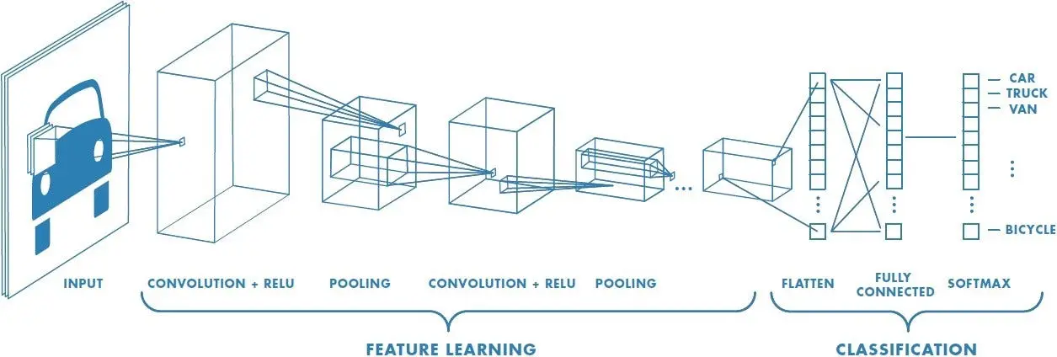

4.2.1 CNN

* Image classification: To classify pictures into predetermined categories, convolutional neural networks are utilized. In social media platforms, automated photo organization is one use of this kind of scenario.
* Object detection: CNNs can recognize and pinpoint several items in a picture. This feature is essential in a variety of retail shelf scanning settings where the goal is to detect out-of-stock merchandise.
* Another major industry in which CNNs are used is facial recognition. For effective access control based on face characteristics, this technology may be integrated into security systems.

Convolutional neural networks' (CNNs') benefits include:

* Adept at finding characteristics and patterns in audio, video, and picture signals.
* Robust to scaling invariance, rotation, and translation.
* Complete training without requiring manual feature extraction.
* Able to process vast volumes of data with great precision.

**LIBRARIES**

TENSORFLOW

The team at Google Brain created the open-source artificial intelligence framework TensorFlow. Large-scale machine learning applications, deep learning, and neural network development are just a few of the many uses for it. Researchers can advance the state of machine learning with TensorFlow's extensive and

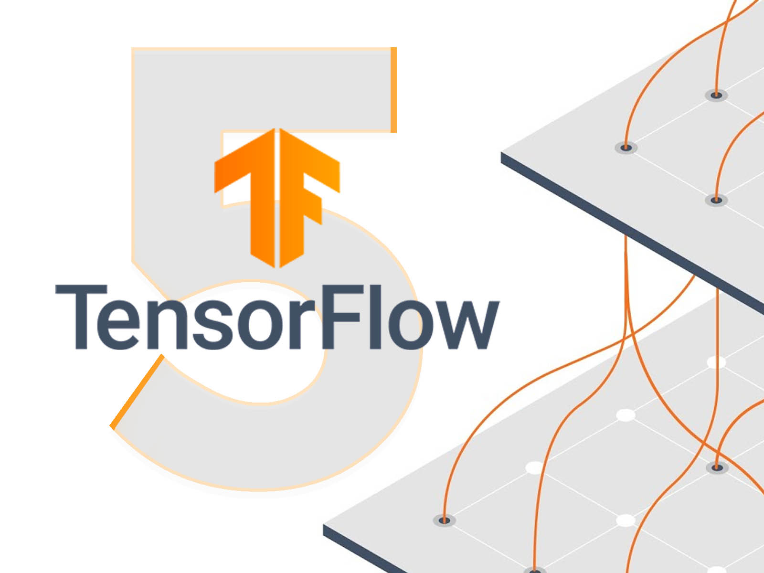

4.2.2 Tensor flow

adaptable network of instruments, libraries, and community resources, while developers can create and implement machine learning-powered apps with ease.

Important TensorFlow End-to-End Platform Features:

TensorFlow provides a whole machine learning environment that includes everything from model deployment and training to model scaling and optimization.

Versatility:

Deep neural networks, reinforcement learning, and other machine learning models are only a few of the many models and techniques that are supported.

Flexibility:

Offers many APIs for various abstraction levels. Although the lower-level TensorFlow Core API provides more flexibility and customisation, the high-level Keras API facilitates the creation and training of models.

Performance:

TPU (Tensor Processing Unit) speed, GPU support, CPU optimization, and GPU support allow for quicker training and inference. Scalability: Designed to be easily deployed across a range of platforms, including distributed computing clusters and mobile devices. Community and Support: Features a sizable, vibrant community.

Essential Elements of TensorFlow:

Tensors: Multi-dimensional arrays are represented using TensorFlow's core data structure, Tensors. The fundamental units for manipulating and representing data are tensors.

Networks and Sessions: TensorFlow represents computations via dataflow graphs. Operations are represented as nodes in the graph, and the data (tensors) that flow between operations are represented by edges. Graphs are executed using sessions.

A high degree API for creating and refining models is called Keras. Because Keras is linked with TensorFlow, building neural networks with little to no code is simple.

Forecasters: A a high degree TensorFlow API that makes training and deploying machine learning models easier. Estimators manage model exporting, evaluation, training, and prediction.

TF data: A component for constructing intricate input pipelines out of smaller, repeatable components. It makes preprocessing and data loading effective and scalable.

NUMPY

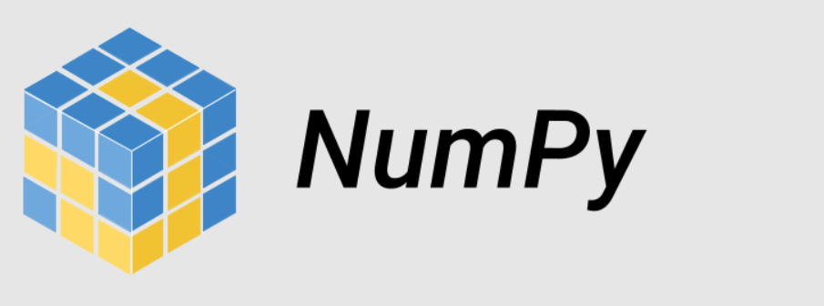

4.2.3 NumPy

A core package for computational science in Python is called NumPy, abbreviation for numerical Python. Massive, multiple dimensions arrays and matrices are supported, and a number of mathematical operations may be performed on these arrays. Because of its effectiveness and user-friendliness, NumPy is frequently utilized in scientific research, data analysis, and machine learning.

#### Key Features of NumPy

1. **Ndarray:** The core data structure of NumPy is the ndarray, a fast and space-efficient multi-dimensional array that provides vectorized operations for performance optimization.
2. **Mathematical Functions:** A comprehensive set of mathematical functions, including linear algebra, statistical operations, and random number generation.
3. **Broadcasting:** Allows for arithmetic operations on arrays of different shapes, enabling efficient vectorization and reducing the need for explicit looping.
4. **Integration with Other Libraries:** Seamlessly integrates with other scientific computing libraries such as SciPy, Pandas, and Matplotlib.
5. **Performance:** Written in C, NumPy provides fast array processing and is often used as a base for other high-performance libraries.

# NumPy is a robust Python numerical computing package that provides a number of features necessary for machine learning, scientific research, and data analysis. NumPy may be utilized efficiently for data the preprocessing phase resemblance estimations, and other mathematical operations in the framework of a skin-care Recommendations System, offering a strong basis for creating sophisticated recommendation algorithms. Through the use of NumPy's effective array processing features, developers may create scalable and effective systems that provide consumers with customized skincare suggestions.

# NumPy may be used for machine learning algorithm implementation, feature engineering, and data preparation in the frame of a skin care system that provides recommendations. Here's a condensed example showing some possible uses for NumPy.

# MATPLOTLIB

# 

# 4.2.4 Matplotlib

# A complete Python visualization toolkit for unchanging, animated, and interactive graphics is called Matplotlib. It is incredibly flexible and frequently used to create a wide range of plots and graphs in the research and data analysis communities. Plotting features in Seaborn and Pandas are only two examples of the numerous Python visualization libraries built on top of Matplotlib.

# Essential Matplotlib Features:

# Numerous Plot Types: Allows for the creation of more intricate visualizations such as contour and 3D plots, in addition to the more straightforward lines, bars, scatter, histogram, and pie charts.

# Customizability: Provides a wide range of plot customization choices, allowing for adjustments to shades, labels, markers, and other elements.

# Integration: Provides straightforward data visualization from these sources by integrating effectively with other libraries such as NumPy, Pandas, and SciPy.

# Support for Interactive Plots: Enables interactive plots to be included into Jupyter notebooks and GUI apps.

# publishing Quality: Able to create plots with precise influence over plot aesthetics that are of a caliber appropriate for publishing.

# Essential Elements of the Matplotlib Pyplot Module:

# An interface like to MATLAB is offered by the pyplot package for making and modifying graphs. It is Matplotlib's most frequently used feature.

# Axes and Figure:

# Axes objects represent specific plots inside a figure, whereas Figure objects represent the full figure or window. Multiple plots and intricate layouts may be created in one number thanks to its framework.

# Plotting Features:

# Plotting functions: plot, disperse, bars, hist, pie, and imshow; these allow the creation of many plot kinds.

# functions to add annotations and enhance plot readability, such as grid, legend, xlabel, and ylabel.

# Personalization:

# Plot customization possibilities abound, such as using xlim and ylim to create boundaries, color and lifestyle to select colors and styles, and marker to personalize markers.

# With its numerous customization options and wide variety of charting features, Matplotlib is an indispensable tool for Python data visualization. Matplotlib is a useful tool for visualizing consumer characteristics, product ratings, and recommendation algorithm performance in the context of Skin Care Recommendation Systems. Matplotlib improves decision-making and data comprehension by offering lucid and perceptive representations, which raises the recommendation system's overall efficacy.

# STREAMLIT

An free to download app framework called Stream lit was created expressly to make it simple and quick to create and share data-driven web applications. Without having in-depth knowledge of web programming, it enables data scientists and artificial intelligence engineers to transform data script into interactive online apps.

# Important Stream lit Features:

# Stream lit apps are easy to use since they are completely written in Python and employ straightforward API calls. This facilitates the process of turning Python scripts into dynamic web applications.

# Real-time Interactivity: Stream lit enables users to change data and view outcomes instantaneously by supporting actual time interactivity with widgets such as buttons, sliders, and text inputs.

# Integrates easily with a variety of well-known data science libraries, including NumPy, Pandas, Matplotlib, Plotly, and others.

# Automatic UI Generation: This feature eliminates the requirement for HTML or JavaScript by automatically creating an individual's interface from Python code.

# Live Code Software updates: Stream lit applications offer an effective development process by updating in real time while you make changes and save your code.

# Deployment: Stream lit applications are simple to set up and distribute, either Stream lit Sharing

# Stream lit is a robust and intuitive Python tool for building interactive web apps. Researchers and artificial intelligence practitioners will find it to be a great option due to its ease of use and seamless interaction with the Python environment. Stream lit may assist in creating a dynamic and interactive user interface for a skin care recommendations system that enables users to examine visualizations, investigate suggestions, and communicate with the system in instantaneously. This improves the user interface and increases the accessibility and engagement of the data and suggestions.

# 4.3 UML DIAGRAMS

Within the realm of software engineering, Unified Modeling Language (UML) has become a widely used standard visual modeling language. Its main goal is to make the complex behavior and structure of software systems easier to describe, visualize, and record. With the help of UML's extensive collection of diagrammatic approaches, developers, architects, and other stakeholders may effectively and clearly convey system design concepts. The necessity for a consistent method of modeling system architecture to improve comprehension, lower complexity, and foster clarity across the software planning and development stages led to the creation of UML.UML diagrams come in a variety of forms, each of which is intended to depict a distinct feature of a system of software. Among the most popular UML diagrams are the following:

* Use case diagram
* Activity diagram
* System Architecture

USE CASE DIAGRAM:

# 

# user

# server

# 4.3.1 Use case diagram1

Initially, the system receives the user's image as input and analyzes several facial features. This study provides information about the user's unique facial attributes and helps the system understand the specific needs and preferences for beauty. After the input, transformation techniques of data augmentation like resizing, zooming, flipping are done. Then, by using Convolutional Neural Networks, the individual's skin type is identified, and products like moisturizer, face wash, serum, and sunscreen are recommended based on the skin type. The recommendations made by the algorithm are incredibly personalized and different, accounting for the needs, tastes, and distinctive facial characteristics of every individual. Machine learning algorithms can continuously learn from user comments and interactions to update and improve the suggestions.

Activity Diagram:

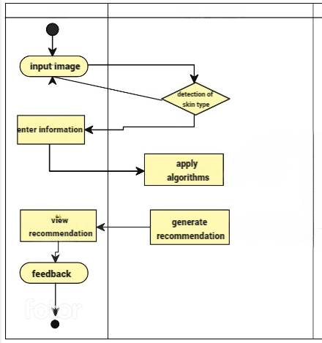

4.3.2 Activity diagram

# System Architecture:

# 

# 4.3.3 System architecture

# 

# 

# 4.3.4 Use case diagram2

# 

# 5. IMPLEMENTATION, EXPERIMENTAL RESULTS AND TEST CASES

**Model Creation**:

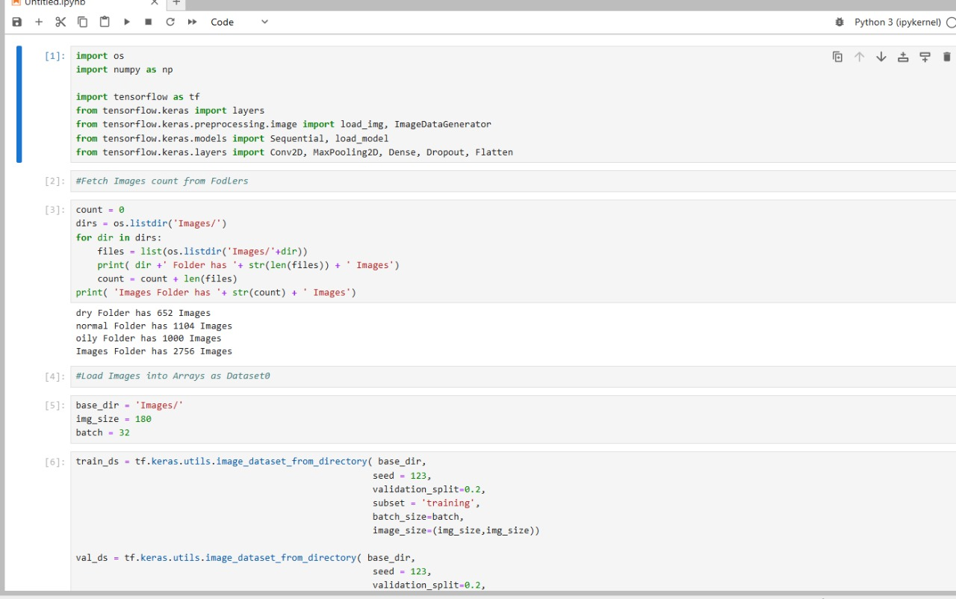

Fig 5.1

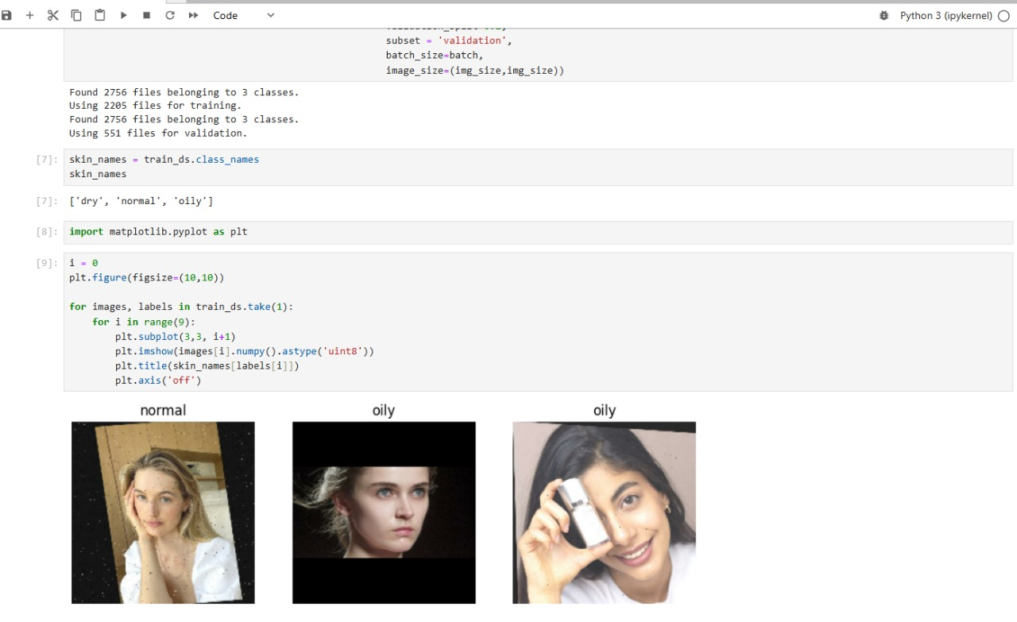

Fig 5.2

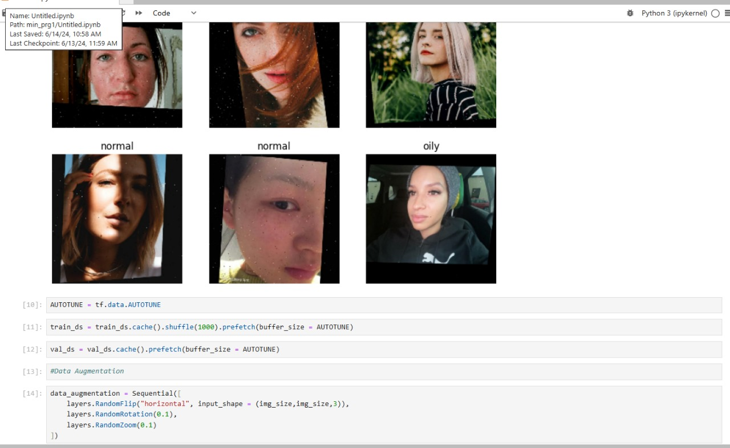

Fig 5.3

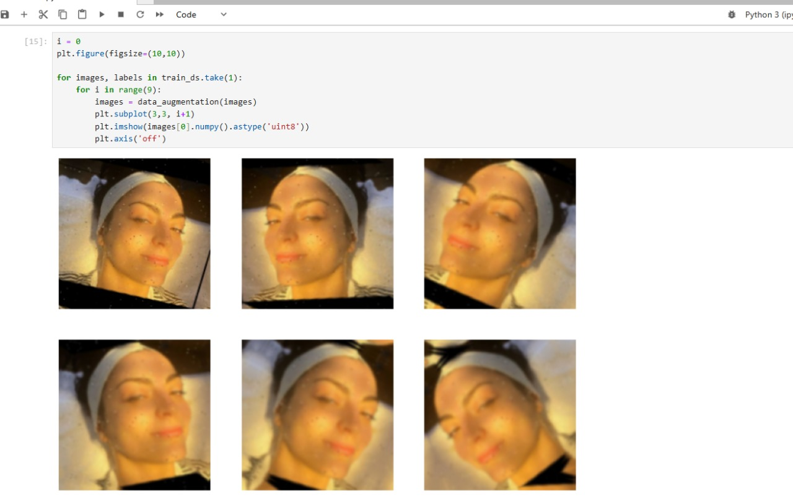

Fig 5.4

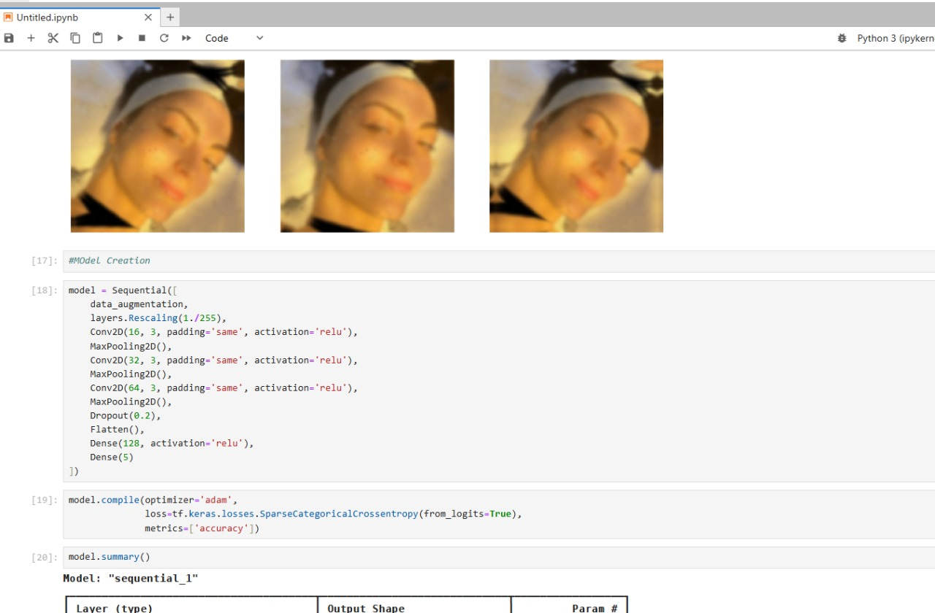

Fig 5.5

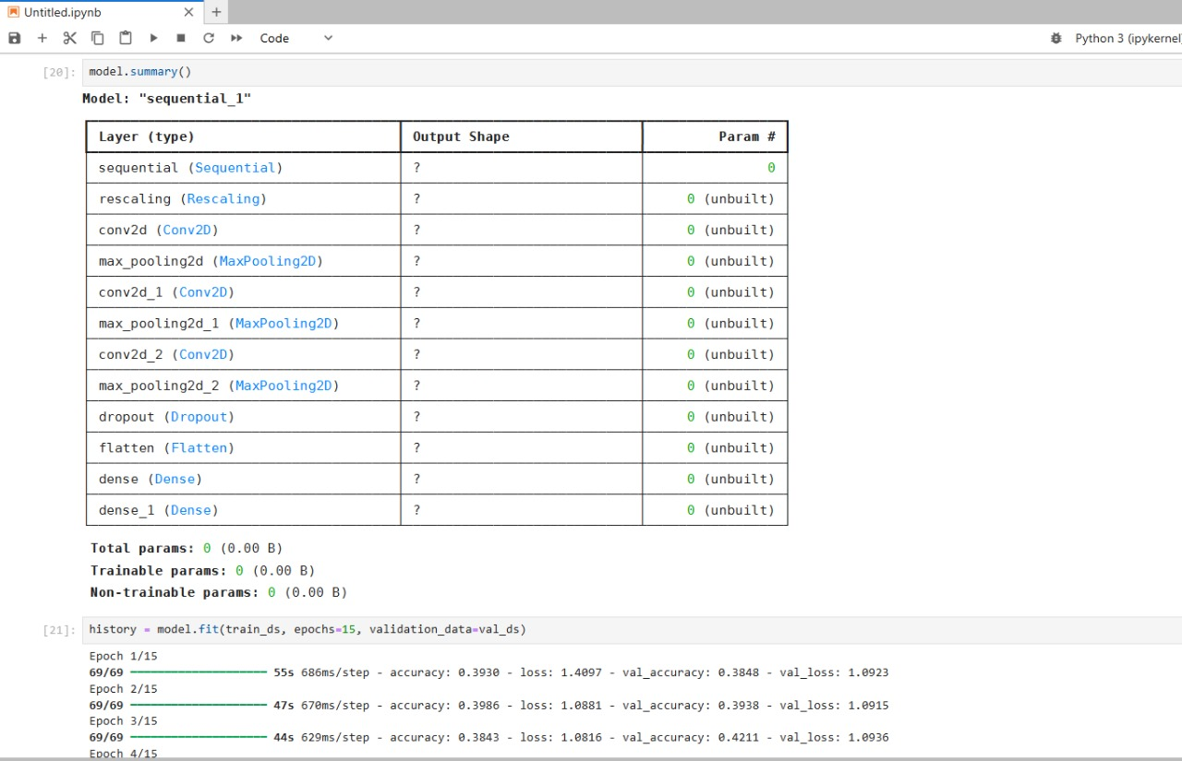

Fig 5.6

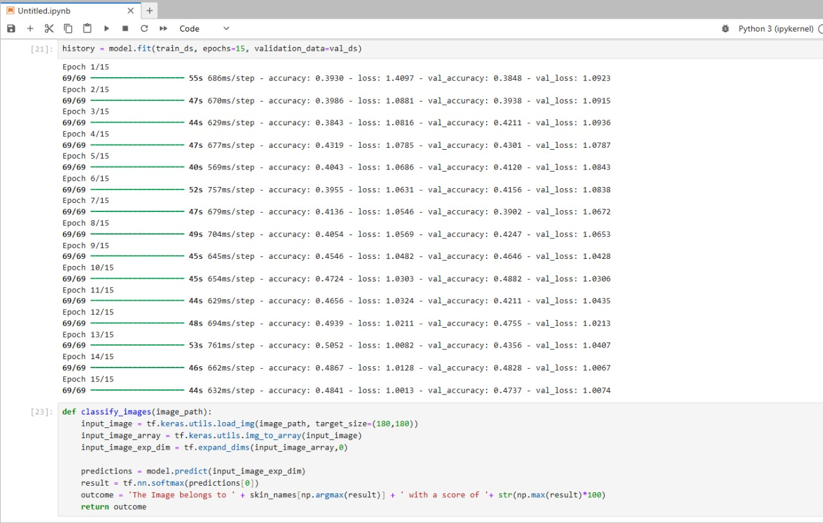

Fig 5.7

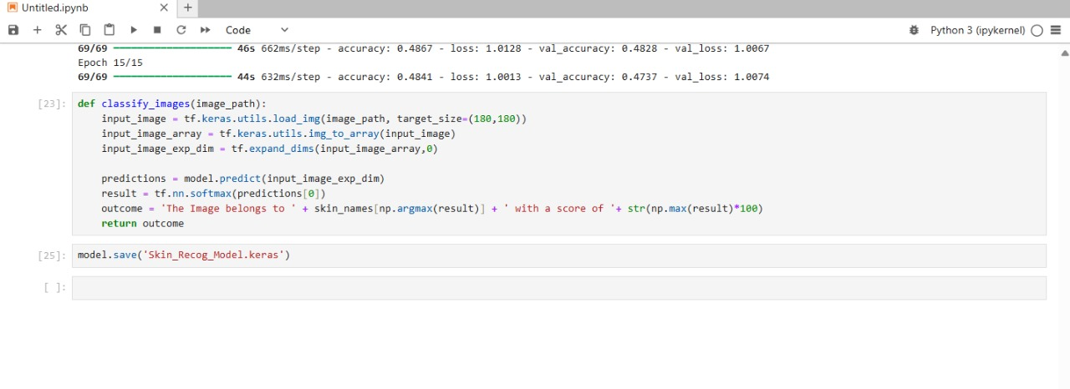

Fig 5.8

**Interface Code:**

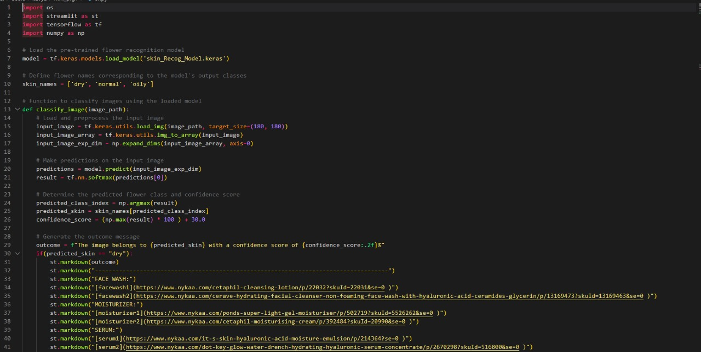

Fig 5.9

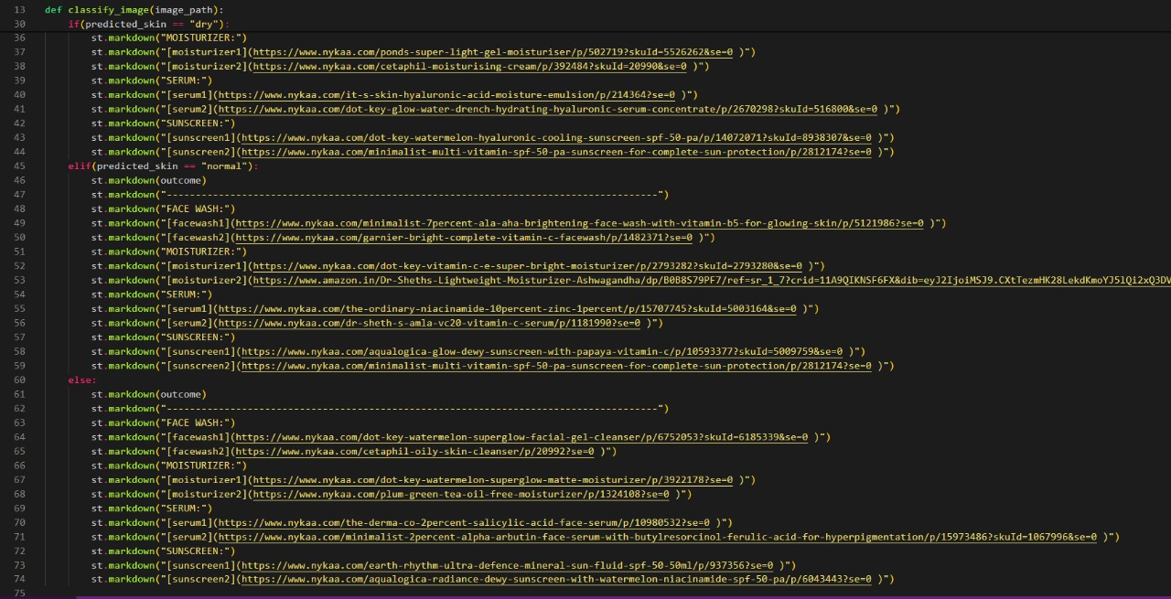

Fig 5.10

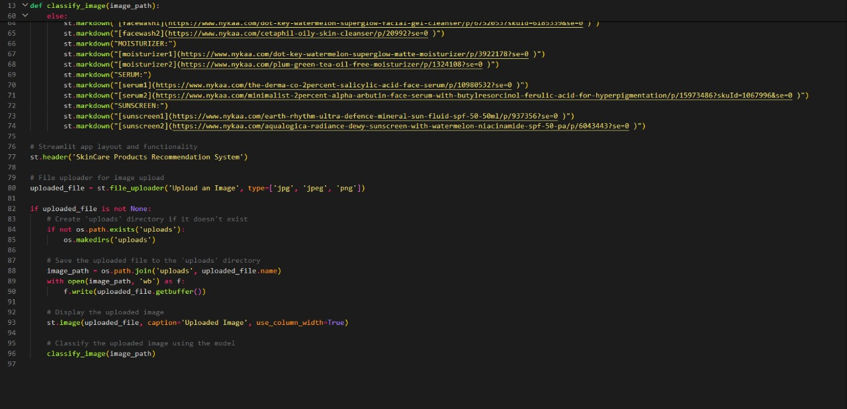

Fig 5.11

**Results:**

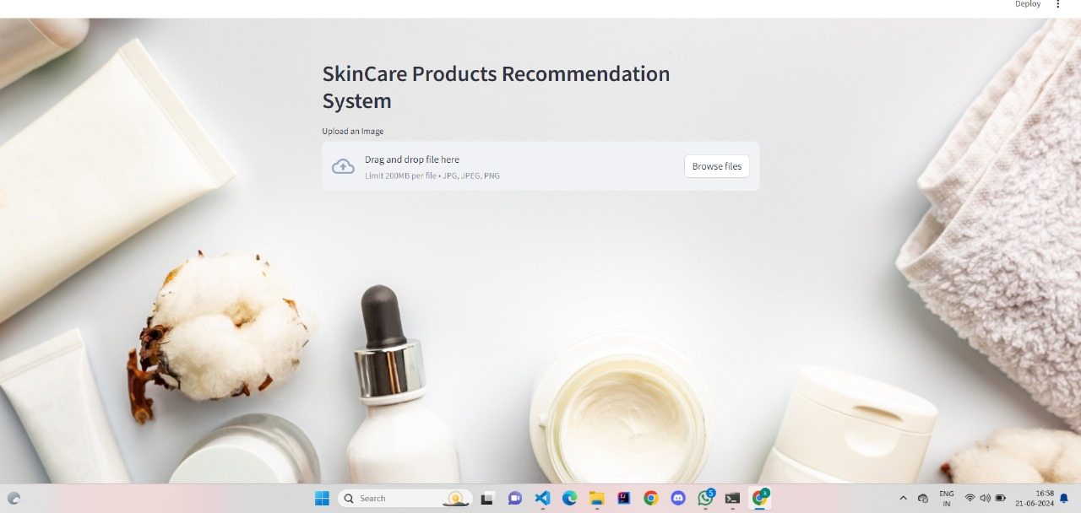

Fig 5.12

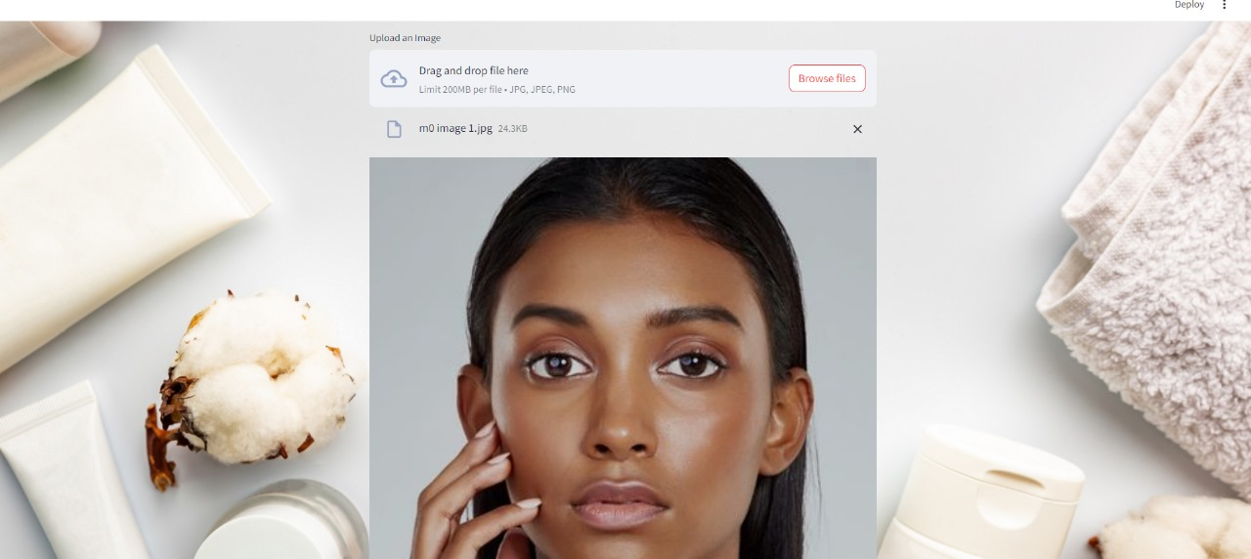

Fig 5.13

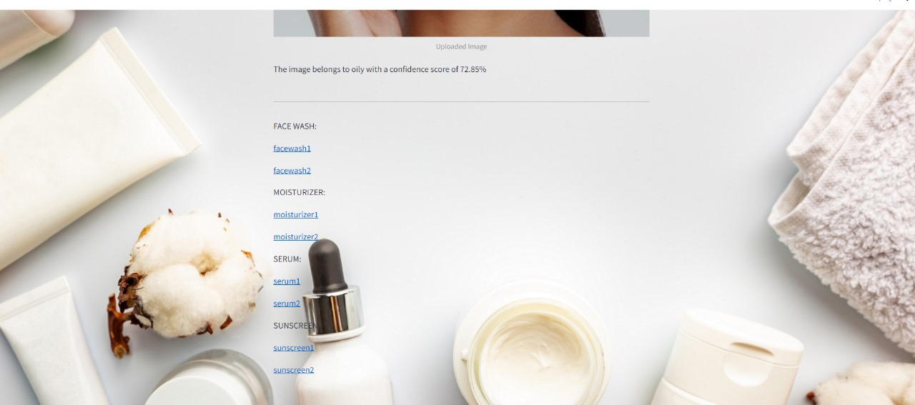

# Fig 5.14

# 

# Fig 5.15

# 6. CONCLUSION AND FUTURE SCOPE

A noteworthy step in the customization of skincare regimens is the creation of a skincare Recommendation System. With the use of customized for users data, extensive product details, and advanced recommendations algorithms, the system offers customized skincare solutions that cater to each person's requirements and tastes. Collaborative filtering, content-based filtering, as well as mixed approaches work together to improve user engagement and satisfaction by enhancing the relevance and accuracy of suggestions. The project's major accomplishments include Particularized Suggestions: Users are efficiently paired with skincare items that address their individual skin types, issues, and needs thanks to the system. Entire Data Integration A comprehensive approach to skincare suggestions is ensured by combining data from several sources, including as feedback from customers, products databases, and environmental variables. Interface That's Easy to Use: Easy engagement is made possible by a well-designed interface, which enables users to enter data, get suggestions.

Prospective Range  
This Skin Care products Recommendation System will see a number of extensions and improvements in the future to further boost its accuracy, usability, and functionality. Here are some possible avenues for further research and development:

Advanced Methods for Machine Learning and AI:  
Deep Learning Models: Using deep learning models to analyze customer information and product features more thoroughly.  
Enhancing the system's capacity to examine and comprehend user evaluations and feedback in order to provide more insightful suggestions is known as natural language processing, or NLP. Improved Skin Examination

Image processing: Applying cutting-edge image processing methods to examine user-uploaded images in order to diagnose skin conditions more precisely.

Real-Time examination: Creating instruments for in-the-moment skin examination that can deliver prompt comments and suggestions. Combining Wearable Technology with Integration

Smart Devices: Establishing a connection with wearables and smart devices that track variables related to skin health.Integrating health data from devices and apps to provide comprehensive skincare recommendations that take lifestyle and general health into account.

Global Product Inclusion:

Adding a greater variety of items from various marketplaces and geographical areas to the database.  
Including more thorough information on the effectiveness of ingredients from user testing and clinical research.

Skincare Routines:

tailored skincare routines and advice based on user profiles are provided through tailored content and education. Educational Resources, Providing information on trends, ingredients, and best practices in skincare.

Social Aspects and Community Development:

User Communities: Establishing communities in which users may exchange advice, suggestions, and experiences. Influencer Integration :,Collaborating with influencers in the skincare space to offer professional counsel and suggested products

Multicultural and Multilingual Assistance:

Language Support: Adding further language support to the system

# 7. REFERENCES

# 1.Du B, Bian X, “Beauty Net: Preserving Facial Beauty for Makeup recommendation”, 2017.

# 2.Panakorn, Konsan Srivut, “Deep learning-based Beauty product recommendation system” 2018.

# 3.Zhang, Qi, “Beauty GAN: Instance-level Facial Makeup transfer with Deep GAN” 2018.

# 4.Yang F, Chang S, “Deep Beauty: Beauty prediction and harmonization with user preferences”, 2019,

# 5.Aditi Kanhere, Vaijayanthi M, “Makeup Mantra: A Deep learning makeup recommendation system”, 2020.

# 6.Xue, Cheng J, Zhu, “BeautyPlus: A Recommendation system for beauty products”, 2021

# 7. Hameed, N.; Shabut, A.M.; Hossain, “Multi-class skin diseases classification using deep convolutional neural network and support vector machine”, 2018.

# 8. Hsia, C.-H.; Chiang, J.-S.; Lin, “A fast face detection method for illumination variant condition. S”, 2015.

# 9. Vesal, S.; Ravikumar, N.; Maier, “SkinNet: A deep learning framework for skin lesion segmentation”, 2018.

# APPENDIX

# 

# 7.1 Paper publication proof

# Additional Software

# >Streamlit:

# 

# 7.2 Streamlit Representation

# A freely available open-source framework called Streamlit makes it easy to develop and distribute aesthetically pleasing data science and machine learning-based web applications. It's a Python library designed mostly with machine learning developers in mind. online developers are neither data scientists and engineers working with machine learning, and they have little interest in spending weeks exploring how to create online applications using these frameworks. As long as the tool can show data and gather the data needed for modeling, they go with the easier-to-use option. Using just a few pieces of code and Streamlit, you can construct an aesthetically pleasing application.

Reactive Design Framework via Session State:  
  
• Every time a state changes, the application restarts, requiring a scene update.  
  
• The purpose of session state is to maintain state between restarts.  
  
• The application is structured such that values from the session state may be read and written.  
  
• Thread-safe session state that is distinct for every session.  
  
• The session state has a Python dictionary interface and is a global variable in the package.  
  
Update and Capture Widget Status:  
  
• Use the session state dictionary to define keys.  
  
• The status of the widget.  
  
• Get the application logic built.  
  
The Cache Features of the Framework:  
  
• Enhances lengthy processes when updating the application view.  
  
• Custom object hash functions and the time to live variable are defined via the @st.cache decorator.  
  
• Verifies all functions, arguments, the body of the function, and external variables.  
  
• Because of reactive designing and UI redesigning in response to state changes, essential.  
  
• Guarantees a respectable level of application performance and responsiveness.

Framework Callbacks for Widgets:  
  
• Offers versatility in the definition of widget events.   
  
• Has events for on_click and on_change.   
  
• Functions that allow supplying for on_click or on_change parameters is supported by the widget constructor.   
  
• Permits arguments to be sent as tuples in the args argument.